Template:

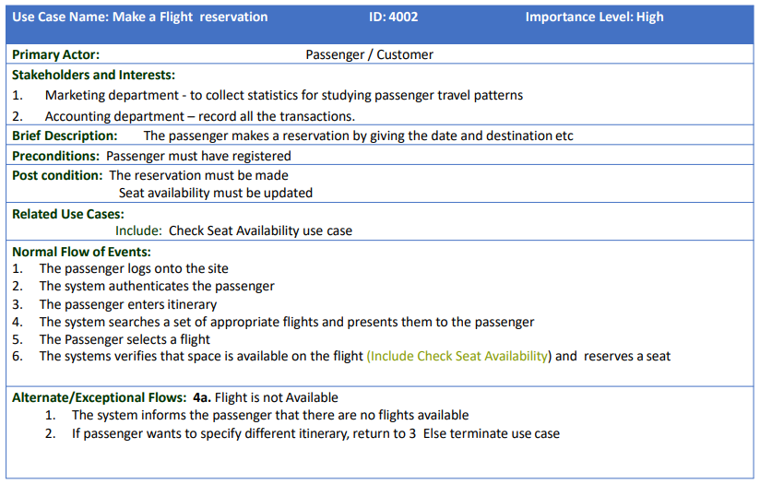

**Use Case Diagram:**

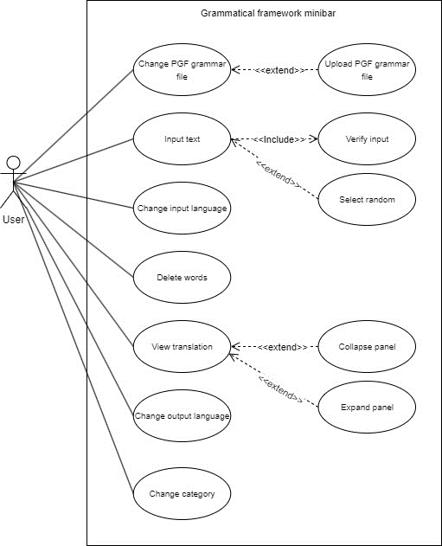

**USE CASE NARRATIVES**